PBL Phase 3: Project Development, Prototype, and Exhibition Preparation Purpose of Phase 3
Phase 3 focuses on moving from research and planning into project development, prototype creation, and exhibition preparation.
At this stage, students should begin showing clearly:
∙ What they are going to create
∙ How their research supports their idea
∙ What materials, equipment, space, or technology they need
∙ How their project will work
∙ How the project will be presented at the exhibition
∙ What visitors will learn from the project
The final exhibition should not consist only of written research. Each project should develop into a model, prototype, website, experiment, business proposal, interactive demonstration, or another clear exhibition product.
This work can later support the actual exhibition demonstration if appropriate materials and equipment become available.
Amber + Irene + Lyla + Belle – Team Company Project Team Goal
Amber, Irene, Lyla, and Belle are now developing one proposed semiconductor/AI company in Taiwan, inspired by their previous research, including Winstek.
You are no longer developing four completely separate projects. Each person is responsible for one major part of the company:
∙ Amber: Overall business model and investment plan
∙ Irene: Problems, risks, and solutions
∙ Lyla: AI business branch
∙ Belle: Training and education business branch
All four parts must eventually connect into one complete company proposal. Your team should be able to explain:
1. What the company does
2. What products and services it provides
3. Who its customers are
4. How the company earns money
5. What equipment it needs
6. What facilities/buildings it needs
7. What employees/workers it needs
8. What technology it needs
9. What suppliers and partners it needs
10. What initial investment may be required
11. What problems and risks the company may face
12. How the company will solve or reduce those problems
13. How AI creates additional business and revenue
14. How training develops skilled workers and generates additional income 15. Why an investor should consider investing in the company 16. How the company can grow in the future
For the exhibition, combine all four sections into one company display/model.
Visitors should be able to follow the company from its services and operations through its costs, risks, AI services, training programs, customers, and final revenue/business results.
The team should eventually be able to present the company to an investor by explaining:
“This is our semiconductor/AI company. This is what we will do, how the company works, how we will earn money, what investment we need, what risks we face, how we plan to solve those problems, and why the business can grow.”
Amber – Business Model and Investment Plan
You are responsible for developing the overall business model of the proposed company.
Use your previous Winstek research as a real-world reference, but remember that the final business should be your team's own proposed semiconductor/AI company.
Step 1 – Define what the company sells
Identify:
∙ Products
∙ Services
∙ Semiconductor-related services
∙ Other business services
Step 2 – Identify customers
Explain:
∙ Who the customers are
∙ Why they need the company's services
∙ How customers will pay the company
Step 3 – Identify revenue
Explain the company's major:
∙ Revenue sources
∙ Methods of generating income
Step 4 – Identify expenses and investment requirements
Research:
∙ Main expenses
∙ Equipment
∙ Facilities/buildings
∙ Employees
∙ Technology
∙ Suppliers
∙ Partners
∙ Initial investment requirements
Step 5 – Explain how the company operates
Explain how the company's different sections connect:
∙ Semiconductor services
∙ AI branch
∙ Training/education branch
∙ General company operations/management
Step 6 – Explain customer development and future growth Research:
∙ How the company will attract customers
∙ Why customers would choose the company
∙ Future growth opportunities
Step 7 – Prepare a business-flow diagram
Create a simple diagram showing the connection between:
Customers → Services → Company Operations → Costs/Investment → Revenue/Profit
Also show how the AI and training branches connect to the main company. Step 8 – Prepare the investment case
Explain:
∙ How much initial investment may be needed
∙ What the investment will be used for
∙ Why an investor should consider investing
∙ How the company could operate successfully and generate profit Why this is important
Amber's work explains to visitors and investors how the entire company works and makes money.
Your research will form the main Business Model and Investment section of the team's exhibition model and investment presentation.
Lyla – AI Business Branch
You are responsible for designing the AI department/branch of the proposed semiconductor company.
Your main question is:
How can AI become a product or service that generates additional profit for the company?
Step 1 – Research possible AI services
Research how AI can help semiconductor companies or become a service that other companies may pay for.
Possible areas include:
∙ AI chip inspection
∙ AI defect detection
∙ Predictive equipment maintenance
∙ Semiconductor data analysis
∙ Production optimization
∙ AI customer support
∙ Semiconductor training AI
∙ Other useful AI services
Step 2 – Select the strongest ideas
For each selected AI service, explain:
What it does → Who needs it → What problem it solves → Why they need it → How it connects to the semiconductor company → How the company earns money from it
Step 3 – Identify resources
Explain what the AI department needs, including:
∙ Employees/workers
∙ Computers
∙ Software
∙ Data
∙ Technology
∙ Other necessary resources
Step 4 – Connect your branch to the team company
Work with Amber and Irene so that:
∙ Your AI business fits Amber's overall business model.
∙ Your AI risks and requirements connect with Irene's risk-and-solution work. Step 5 – Develop a prototype if possible
Your priority is to create a working version of your AI and provide a usable link before adding unnecessary extra features.
If possible, develop a simple working AI prototype that visitors can test at the exhibition.
Why this is important
The AI branch demonstrates how the company can create:
∙ Additional revenue
∙ New products/services
∙ Future growth opportunities
Your AI branch should appear clearly as one part of the final company exhibition model.
Belle – Training and Education Business Branch
You are responsible for designing the company's training and education department.
Use your previous research about TSMC training, but now develop it into a business service that can also generate revenue.
Step 1 – Identify the target students
The training program may serve:
∙ University students
∙ High-school students
∙ New semiconductor employees
∙ People preparing for semiconductor careers
Our training center is for:
- University students
  - Learn basic semiconductor knowledge.
  - Get hands-on experience.
- High school students
  - Learn about semiconductors.
  - Explore future career choices.
- New semiconductor employees
  - Learn about equipment, processes, and safety.
  - Get ready for their jobs.
- The people who want to work in the semiconductor industry
  - Learn the skills they need.
  - Prepare for a semiconductor career.

Step 2 – Decide what courses will be provided
Possible courses include:
∙ Semiconductor basics
∙ Equipment training
∙ Process training
∙ Cleanroom and safety
∙ AI/intelligent manufacturing
∙ Hands-on semiconductor activities
Our training center has these courses
- Semiconductor Basics — Fundamentals of Semiconductor Devices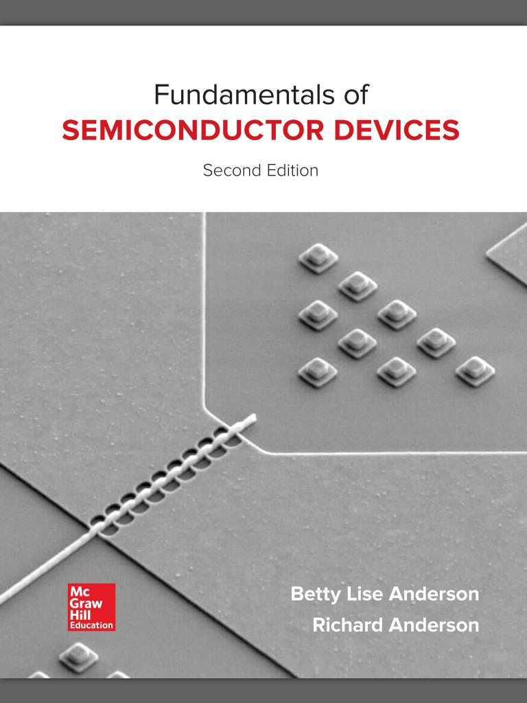
- Semiconductor Process — Semiconductor Manufacturing Technology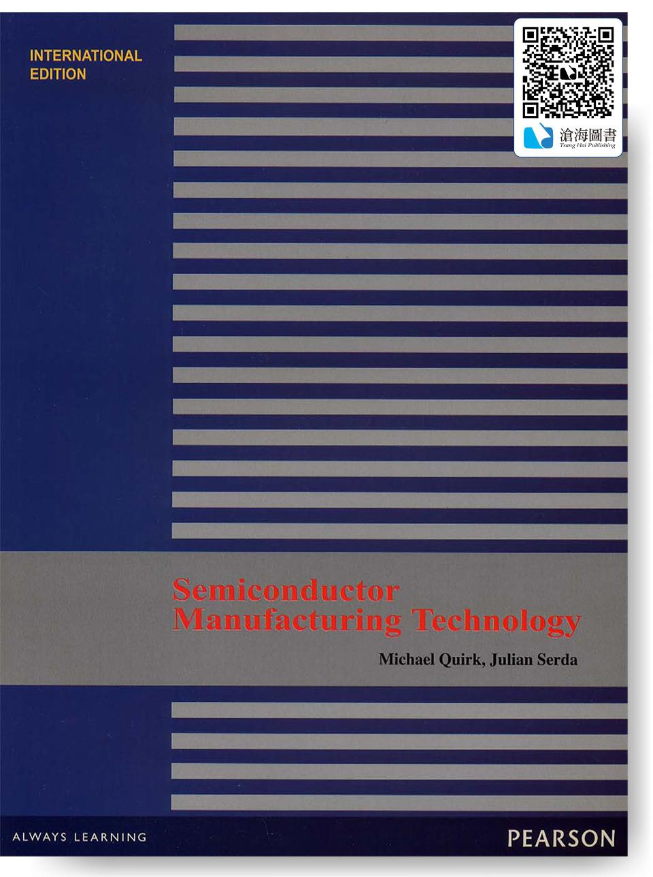
- Equipment Training — Semiconductor Manufacturing Technology
- Cleanroom and Safety — Semiconductor Safety Handbook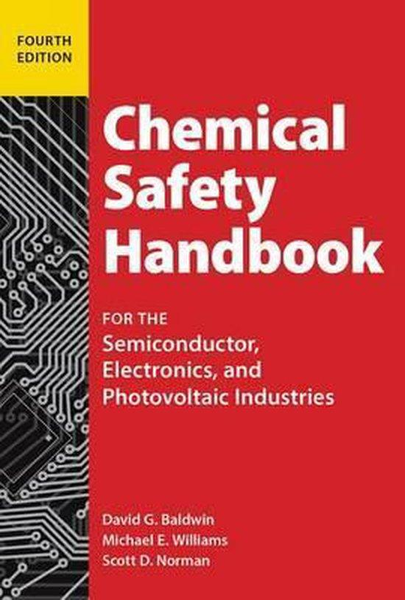
- AI and Programming — Python Crash Course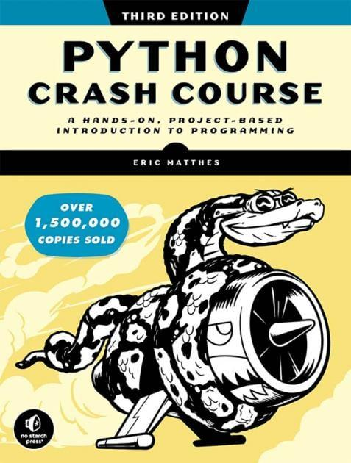
- Hands-on Practice — Semiconductor Processes and Integration
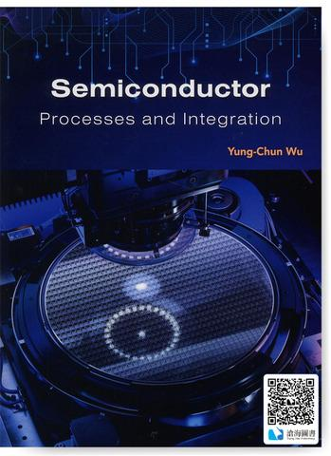
Students can choose classes based on their level:
- Basic: Basics and Safety
- Intermediate: Process and Equipment
- Advanced: AI, Programming, and Practice

Step 3 – Plan the training spaces
Decide exactly what rooms/classrooms/training areas are required. For each room, identify:
∙ Course/training taking place there
∙ Approximate room size
∙ Number of students it can hold
∙ Important equipment required

Student Training Plan
Step 1: Register
Students sign up for courses.
Step 2: Check Level
Teachers check students' levels.
Step 3: Learn Basics
Students learn basic semiconductor knowledge.
Step 4: Learn Safety
Students learn safety rules.
Step 5: Learn Skills
Students learn processes, equipment, AI, and programming.
Step 6: Practice
Students practice with equipment.
Step 7: Take a Test
Teachers check students' skills.
Step 8: Get a Certificate
Students who pass get a certificate.

Room / Area | Use | Size | Students / People | Important Equipment
1.Classroom A | Semiconductor Basics | 60 m² | 20 | Desks, chairs, whiteboard, projector
2.classroom B | Semiconductor Process | 60 m² | 20 | Desks, chairs, whiteboard, projector
4.Computer / AI Lab | Computer, AI, and programming | 65 m² | 15 | Computers, projector
5.Equipment Training Room | Equipment training | 80 m² | 15 | Training equipment, tools
6.Process Training Lab | Process practice | 100 m² | 15 | Process equipment, tools
7.Cleanroom Training Room | Cleanroom and safety | 80 m² | 15 | Cleanroom equipment, safety equipment
8.Hands-on Lab | Wafer and testing | 80 m² | 15 | Wafers, testing equipment
9.Equipment Room | Equipment practice | 60 m² | 15 | Semiconductor equipment, tools
10.VR / Safety Room | Safety practice | 50 m² | 15 | VR equipment, safety equipment
11.Student Dormitory Area | Rooms, bathrooms, and laundry | 210 m² | 30 beds | Beds, lockers, washing machines
12.Dormitory Common Area | Rest and talk | 40 m² | 15 | Tables, chairs, sofas
13.Cafeteria / Coffee Area | Eat and drink | 100 m² | 30 | Tables, chairs, refrigerators
14.Student Rest Area | Rest and table tennis | 100 m² | 20 | Sofas, tables, table tennis table
15.Staff Area | Teacher and employee rest | 40 m² | 10 | Tables, chairs, lockers
16.Office Area | Office work | 50 m² | 10 | Desks, computers, printers
17.Meeting Room | Meetings | 40 m² | 15 | Table, chairs, projector
18.Public Restrooms | For students and staff | 140 m² | — | Toilets, sinks, hand dryers
19.Storage Area | Store things | 30 m² | — | Shelves, cabinets
20.Security Area | Security | 20 m² | 2 | Monitors, computers, cameras
21.Corridors and Stairs | Walking and moving | 300 m² | — | Lights, signs, handrails
22.Elevator Area | Go to other floors | 25 m² | — | Elevator, control panel
23.Electrical and Mechanical Area | Electricity and air-conditioning | 110 m² | — | Electrical equipment, air-conditioning equipment
24.Cleanroom Air System Area | Cleanroom air system | 40 m² | — | Air filters, air system
25.IT Area | Computers and network | 20 m² | — | Servers, network equipment
26.Cleaning Area | Cleaning supplies | 10 m² | — | Cleaning tools, shelves
27.Garbage and Recycling Area | Garbage and recycling | 20 m² | — | Bins, recycling containers
28.Equipment Repair Area | Repair equipment | 30 m² | — | Tools, workbench
29.Fire Control Area | Fire safety | 15 m² | — | Fire alarm system, control panel
30.Loading Area | Move equipment | 80 m² | — | Loading equipment, carts
31.Emergency Training Area | Safety training | 100 m² | 20 | Fire extinguishers, safety equipment
32.Bus / Drop-off Area | School bus and student drop-off | 150 m² | — | Bus stop, signs
33.Small Parking Area | Staff and visitor parking | 100 m² | — | Parking signs
34.Outdoor Rest / Green Area | Rest and plants | 60 m² | 20 | Benches, plants

Total Area
Indoor area: 1,975 m²
Outdoor area: 490 m²
Total site area: about 2,465 m²

People
About 120 people at one time
About 100 students
About 20 teachers and staff
Regular classes: 20 students
Lab classes: 15 students

Step 4 – Plan hands-on learning
Decide:
∙ What hands-on activities will be included
∙ What training equipment is needed
∙ What facilities students will use
∙ How students will gain practical experience
- Wafer practice
  - Students practice using wafers.
- Equipment practice
  - Students learn how to use semiconductor equipment.
- Process practice
  - Students practice basic semiconductor processes.
- Cleanroom practice
  - Students learn how to work safely in a cleanroom.
- Testing practice
  - Students practice testing semiconductor products.
- AI and programming practice
  - Students use computers to practice AI and programming.

Step 5 – Plan how the training business operates
Explain:
∙ Who can enroll
∙ How students will enroll
∙ How long courses will last
∙ How the training program operates
∙ How enrollment/course fees can generate income

Step 5: Business Operation
- Students: High school students, university students, and new workers.
- Registration: Students register online.
- Test: Students take a simple test.
- Classes: Students join a class based on their level.
- Course time: 1 week to 3 months.
- Class size: 15–20 students.
- Money: Students pay for the courses and dormitory.

Step 6 – Connect training to the company
Explain how the training center supports the company's need for skilled workers. Submission
- Students learn useful skills.
- Students get practice.
- Students learn safety.
- Companies can find trained workers.

Today: Upload details of the required rooms/classes, including:
∙ Course/training
∙ Approximate room size
∙ Student capacity
∙ Important equipment
This information will later be used to create the company's training-center floor plan and model.
Why this is important
The company needs skilled workers, but the training center can also operate as a separate business service that generates revenue.
Your design will form the Training and Education section of the final company model and exhibition presentation.

Irene – Company Problems, Risks, and Solutions
You are responsible for investigating:
What problems could this proposed semiconductor/AI company face, and how can the company prepare solutions before those problems happen?
Step 1 – Examine every major part of the company
Look for possible problems involving:
∙ Employees/talent
∙ Equipment failure
∙ Semiconductor manufacturing
∙ Quality control
∙ Electricity
∙ Water
∙ Materials
∙ Suppliers
∙ Production capacity
∙ Safety
∙ Environment
∙ Finance
∙ Customers
∙ Competition
∙ Supply chain
∙ Technology changes
Step 2 – Organize the risks
Group the problems into clear business areas such as:
∙ Workers
∙ Equipment
∙ Production
∙ Materials
∙ Electricity
∙ Water
∙ Finance
∙ Customers
∙ Competition
∙ Supply chain
∙ Technology
∙ Safety/environment
Step 3 – Explain every major problem using the same structure For each problem, write:
Problem → Why/Cause → Effect on the Company → Solution/Backup Plan Step 4 – Prioritize serious risks
Focus especially on problems that could:
∙ Stop company operations
∙ Interrupt production
∙ Reduce quality
∙ Lose customers
∙ Increase costs
∙ Cause the company to lose money
Step 5 – Coordinate with Amber
Discuss your risks and solutions with Amber so that the risks you investigate match the company's actual business model.
Why this is important
Investors need to understand not only how the company could make money, but also:
∙ What could go wrong
∙ How serious the risks are
∙ How the company plans to manage those risks
Your research will become the Risk and Solution section of the company's investment proposal and exhibition model/presentation.
Link:
https://esg.tsmc.com.tw/en-US/articles/271?utm_source
https://esg.tsmc.com.tw/file/public/e-AnAdmiredEmployer.pdf?utm_source
https://www.tsmc.com/static/english/careers/inclusive_workplace.htm
https://www.tsmc.com/static/english/careers/it_career/index.html
https://www.tsmc.com/static/abouttsmcaz/index.html

